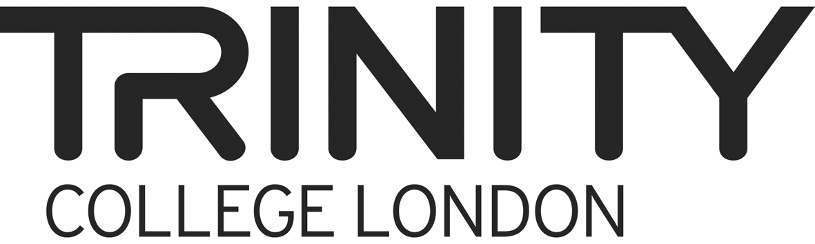 | Trinity Stars Audio-recording form

Please complete this form electronically with feedback session recordings only (up to six) and return it on your data stick with your recordings to Trinity’s London office by 31 August 2014. There is no self-evaluation exercise to complete.

Expert Name: ……………………………………….....…….....… Expert Number: ……………............ Dated: ...............................................................

Monitor Name (if applicable): ………………………………………………………………………………................ Monitor Number (if applicable): ……………………

 | For completion by expert
File name/no. |  | Date | Centre no. | Performances observed in session (Stage 1/2/3/School Show) | Expert’s comments on feedback session  (if relevant)
WS450347  EXAMPLE |  | 23.05.2014  EXAMPLE | 23178  EXAMPLE | Stage 1 and 2 only  EXAMPLE | Session went well, Ts receptive. No issues.  EXAMPLE

Please make any additional comments here:

